## **What is Loss Function in Deep Learning?**

In deep learning, a loss function, also known as a cost function or objective function, is a measure of how well a model's predictions match the actual target values. It quantifies the error between the predicted values and the ground truth across the training data. The goal of training a deep learning model is to minimize this loss function, thereby improving the model's ability to make accurate predictions.

The choice of loss function depends on the specific task being addressed.:-

1. **Regression tasks:** Mean Squared Error (MSE) is commonly used as the loss function. It calculates the average squared difference between the predicted and actual values.
2. **Binary classification tasks:** Binary Cross-Entropy Loss (also known as Log Loss) is often used. It measures the difference between the true binary label and the predicted probability distribution.
3. **Multi-class classification tasks:** Categorical Cross-Entropy Loss is frequently used. It measures the dissimilarity between the true distribution and the predicted distribution.
4. **Sequence prediction tasks:** Sequence-to-Sequence tasks like language translation or text generation often use sequence-based loss functions such as Connectionist Temporal Classification (CTC) loss or Sequence Cross-Entropy.

## Why Loss Function in Deep Learning is Important?

Loss functions play a critical role in deep learning for several reasons:

1. **Optimization:** Loss functions provide a measure of how well a model is performing on the training data. By quantifying the difference between predicted and actual values, loss functions guide the optimization algorithm (e.g., gradient descent) to update the model parameters in a direction that minimizes this difference. Minimizing the loss function during training leads to better model performance.
2. **Evaluation:** Loss functions serve as a metric for evaluating the performance of a model. After training, the loss function can be calculated on a separate validation or test dataset to assess how well the model generalizes to unseen data. Lower loss values typically indicate better performance, although this depends on the specific problem and choice of loss function.
3. **Task-specific objectives:** Different deep learning tasks require different loss functions tailored to the nature of the problem. For example, regression tasks may use Mean Squared Error (MSE) loss, while classification tasks may use Cross-Entropy loss. The choice of loss function reflects the specific objectives and characteristics of the problem being addressed.
4. **Regularization:** Loss functions can incorporate regularization techniques to prevent overfitting and improve the generalization ability of the model. Regularization terms, such as L1 or L2 regularization, are added to the loss function to penalize large parameter values, encouraging simpler models that are less likely to overfit the training data.
5. **Interpretability:** Loss functions can provide insights into the behavior of the model and the nature of the learning task. By examining how the loss changes during training, researchers and practitioners can gain a better understanding of the model's strengths, weaknesses, and areas for improvement.

## Cost Function vs Loss Function in Deep Learning

"cost function" and "loss function" are often used interchangeably, but they can have slightly different interpretations depending on the context. However, they both refer to the same fundamental concept: a function that quantifies the error or discrepancy between the predicted values of a model and the actual target values.

**1.Loss Function:** The term "loss function" is more commonly used during the training phase of a deep learning model. It refers to a function that calculates the error for a single training example. In other words, it measures how well the model's prediction matches the true target value for a specific input instance. Loss functions are typically differentiable and used to compute gradients during backpropagation, allowing the model to update its parameters to minimize the error.  
**Example:** Mean Squared Error (MSE), Binary Cross-Entropy Loss, Categorical Cross-Entropy Loss.

**2.Cost Function:** The term "cost function" is often used to refer to the aggregate error over the entire training dataset. It represents the average loss across all training examples and is used to evaluate the overall performance of the model. Cost functions are also used to guide the optimization process during training by providing a single scalar value that needs to be minimized.  
**Example:** Mean Squared Error (MSE) as a cost function calculates the average squared difference between all predicted and actual values over the entire dataset.

The terms "loss function" and "cost function" are often used interchangeably, and in many contexts, they refer to the same thing. However, in some cases,

* **1.Loss Function:**
  + Typically used in the context of training a machine learning model, especially in the field of deep learning.
  + Measures the error between the model's predictions and the actual target values for a single training example.
  + Loss functions are designed to be differentiable, enabling the computation of gradients during backpropagation, which is used to update the model's parameters.
  + The goal during training is to minimize the loss function for each individual training example.
* **2.Cost Function:**
  + Often used to refer to the aggregate of the loss functions over the entire training dataset.
  + Represents the overall performance of the model across the entire training dataset.
  + Cost functions are computed by averaging the losses (or sometimes summing them) over all training examples.
  + The optimization process during training aims to minimize the cost function, which involves adjusting the model's parameters to reduce the average error across the entire dataset.

## Loss Function in Deep Learning

1. Regression
   * MSE(Mean Squared Error)
   * MAE(Mean Absolute Error)
   * Hubber loss
2. Classification
   * Binary cross-entropy
   * Categorical cross-entropy
3. AutoEncoder
   * KL Divergence
4. GAN
   * Discriminator loss
   * Minmax GAN loss
5. Object detection
   * Focal loss
6. Word embeddings
   * Triplet loss

## **A. Regression Loss**

### **1. Mean Squared Error/Squared loss/ L2 loss**

To calculate the MSE, you take the difference between the actual value and model prediction, square it, and average it across the whole dataset.

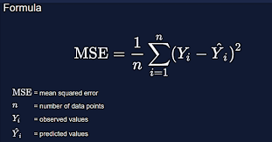

#### **Advantage:-** Easy to interpret, Always differential because of the square and Only one local minima.

#### **Disadvantage:-** Error unit in the square. because the unit in the square is not understood properly, Not robust to outlier

### **2. Mean Absolute Error/ L1 loss**

To calculate the MAE, you take the difference between the actual value and model prediction and average it across the whole dataset.

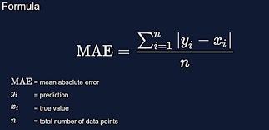

#### **Advantage:-** Intuitive and easy, Error Unit Same as the output column and Robust to outlier

#### **Disadvantage:-** Graph, not differential. we can not use gradient descent directly, then we can subgradient calculation.

### **3. Huber Loss**

The Huber loss is a loss function used in robust regression, that is less sensitive to outliers in data than the squared error loss.

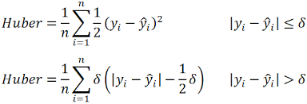

* n – the number of data points.
* y – the actual value of the data point. Also known as true value.
* ŷ – the predicted value of the data point. This value is returned by the model.
* δ – defines the point where the Huber loss function transitions from a quadratic to linear.

#### **Advantage:-**Robust to outlier and It lies between MAE and MSE.

#### **Disadvantage:-**Its main disadvantage is the associated complexity. In order to maximize model accuracy, the hyperparameter δ will also need to be optimized which increases the training requirements.

## **B. Classification Loss**

### **1. Binary Cross Entropy/log loss**

Binary cross entropy compares each of the predicted probabilities to the actual class output which can be either 0 or 1. It then calculates the score that penalizes the probabilities based on the distance from the expected value. That means how close or far from the actual value.

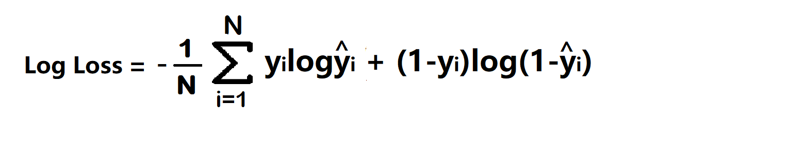

* yi – actual values
* yihat – Neural Network prediction

#### **Advantage –**A cost function is a differential.

#### **Disadvantage –**Multiple local minima and Not intuitive

### **2. Categorical Cross Entropy**

Categorical Cross entropy is used for Multiclass classification and softmax regression.

loss function = -sum up to k(yjlagyjhat) where k is classes

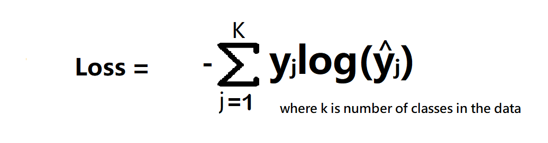

cost function = -1/n(sum upto n(sum j to k (yijloghijhat))

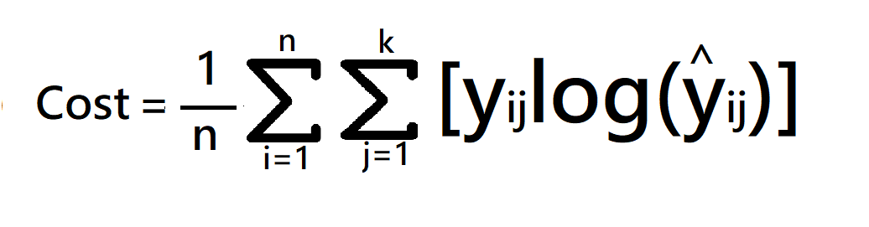

**Where:-** k is classes, y = actual value ,yhat – Neural Network prediction

#### **When to use categorical cross-entropy and sparse categorical cross-entropy?**

If target column has One hot encode to classes like 0 0 1, 0 1 0, 1 0 0 then use categorical cross-entropy. and if the target column has Numerical encoding to classes like 1,2,3,4….n then use sparse categorical cross-entropy.

#### **Which is Faster?**

sparse categorical cross-entropy faster than categorical cross-entropy.